(Approx. 455 words)

Add Bookmarks to Your Word Documents
By Nancy DeMarte, 2nd Vice President,
Sarasota Technology Users Group, FL
July 2018 issue, STUG Monitor
www.thestug.org / ndemarte (at) verizon.net

If you have composed a multi-page Word document, especially if it has a table of contents, you can make it easy to go to specific locations within the document by adding bookmarks. A bookmark is used to jump to a place in a document. It is a cousin to a hyperlink, which is most often used to go to a specific place on the Internet.

Let’s say you have written a tutorial that has a Table of Contents. By adding a bookmark to each section in the tutorial, the reader can go to any section by clicking its title in the Table of Contents. Anything in a document can be bookmarked: text, a picture, or section, for example. Here are steps for creating a bookmark for section 4 of the tutorial below:

TABLE OF CONTENTS
This tutorial includes a few methods for backing up your PC files:
1. Backing up to a flash drive (page 2-3)
2. Backing up to a CD or DVD (page 4-8)
3. Backing up using Windows 7 Backup and Restore (page 9-10)
4. Backing up using Windows 10 File History (page 11)
5. Creating a System Image & System Repair Disk (page 12)
6. Backing up to OneDrive (page 13)

1. Go to and select the title of the chapter where it is located in the document.

4. Backing up using Windows 10 File History

2. On the Insert tab in the Links group, click Bookmark.

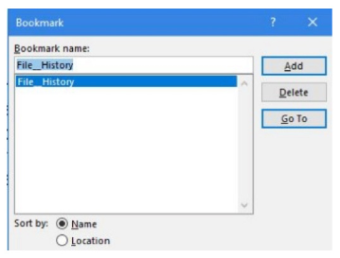
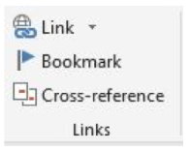
3. Under Bookmark name, type a word or short phrase and click Add. (Bookmark names must begin with a letter and must not contain any spaces. They can also include numbers or underscores, as shown.)

4. Test your bookmark by typing Ctrl+G to open the Go To tab in the Find and Replace tool. In this example, we only have one bookmark (File_History). If you have created several bookmarks, choose the one you want. Then click Go To. You will immediately
jump to the title of that section.
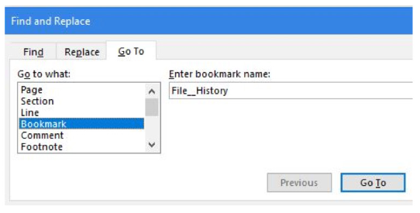

How to add hyperlinks to get to your bookmarks, rather than use the Find and Replace tool. Below are the steps you will need to create hyperlinks to the bookmarks in your document.

1. Right click the word or image you want to become the link and then left click ‘Link’
2. In the ‘Link to’ box, click ‘Place in this Document’ (left pane)
3. In the list, select the bookmark you want to link to, and click OK. Now you can use the keyboard combination, Ctrl+click, with each hyperlink to go directly to its bookmark in the document.

